**CURRENT PROGRAMMING APPLICATION**

***Pet Shop Inventory and Sales System for “Kuya AD’s Petshop”***

**Description:**

This project will focus on creating a software system that will cater to pet shops. A software system that can track inventory levels and orders will enable a business to make those sales. It can also be used to create a work order and keep track of sales, a bill of materials, and other production-related documents.

**Objectives:**

* Achieve an understanding and mastery of the subject fulfillment of our *Current Programming Application* course
* Provide the business with a customized Point-of-Sales and Inventory system that will fit the needs of the shop with accurate and timely data on sales trends, inventory levels, and customer behavior
* To be able to assist with the inventory tracking/ management of products with the concerned shop
* The system will be able to filter inventory levels, product types, and prices from the system’s database
* To record order transaction history that the store has made

**Scope:**

* *Inventory Tracking and Control*. Keeping track and control of the in and out movement of the inventory from the business, as well as any changes made to inventory levels
* *Integrated Inventory Alerts*. Automated notifications that alert the user when the inventory levels of a particular product in stock are below the critical level of inventory
* *Sales Management.* The ability of the system to print out receipts and other financial reports.
* *Reports and Analytics.* The ability of the system to provide to and from sales reports.
* *Cloud Storage.* The inventory management system may be accessed anywhere via a device with the system installed as all data are uploaded to the cloud; an added feature for users looking into multi-store management.
* *Point of Sales.* Computes an item's price, including any applicable sales tax, and then changes the inventory count to reflect the sale of the item and produce an official receipt.
* *Barcode Scanning*. The system will have an external barcode scanner that will translate the barcode into the scanned item’s information, the data will then be sent to a computer and analyzed by the software application.
* *Multi-User Access Control.* Features of the system will vary from user to user depending on their role as dictated by the database.
* *Security.* The system will only be used by authorized users and will be backed up by the SHA-256 algorithm for encryption.

**Limitation:**

* The system is designed to operate in the Windows operating system;
* The prototype will use the Visual Basic 16.9.15 version and will support the .NET 4.5 Version;
* It will support Windows 8 and above;
* The Payment method of the system will only be in cash basis;
* The system requirement will be a 1.8 GHz or faster processor on 32-bit (x86) or 64-bit (x64); Quad-core or better recommended, with 2 GB of RAM; 8 GB of RAM recommended, and a minimum of 800MB up to 210 GB of available space; typical installations require 20-50 GB of free space.

**Proposed by:** 

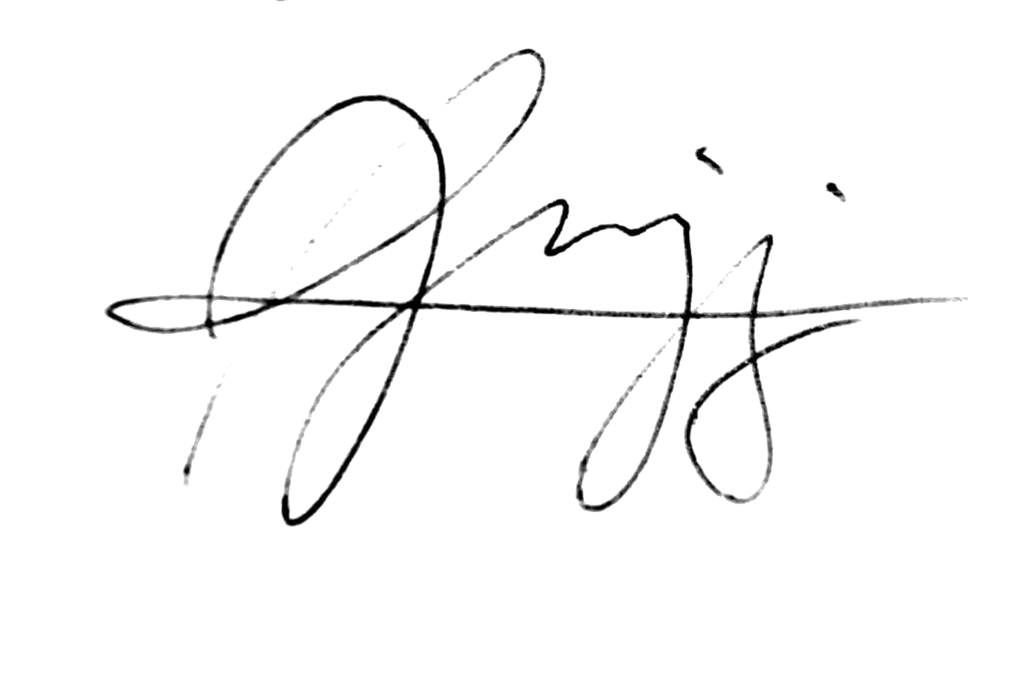

**WENCEL DE LARA JOHN MIGUEL JUSAYAN**



**VINARD JAMES DAMASCO YVAN SINUES**



**HYACINTH ASHLEY RADOVAN**

**Noted by:**

**PROF. JESSIE C. ALAMIL**

Professor, Current Programming Application



**Approved by:**

**JHON MARC SAMARTINO**

Owner, Kuya AD’s Petshop